**Block Matching & 3D filtering (BM3D) for denoising :**

1. **Read our images and convert it into floating point value :**

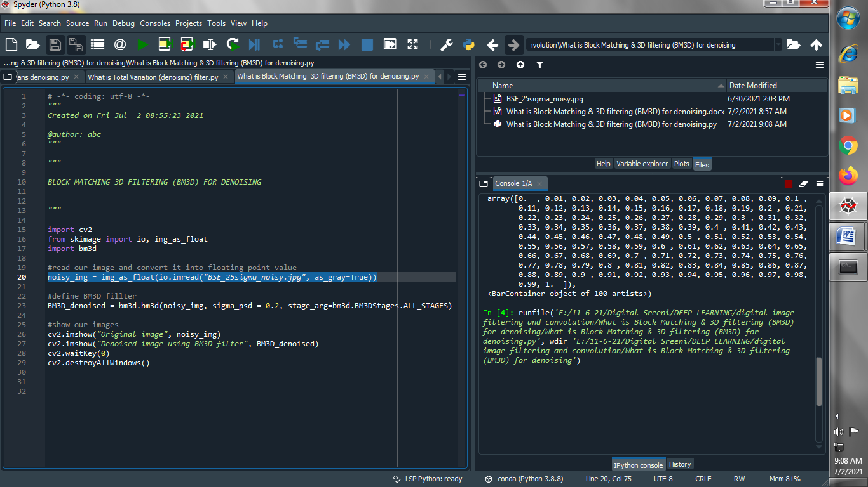

1. **Define BM3D denoising filter :**

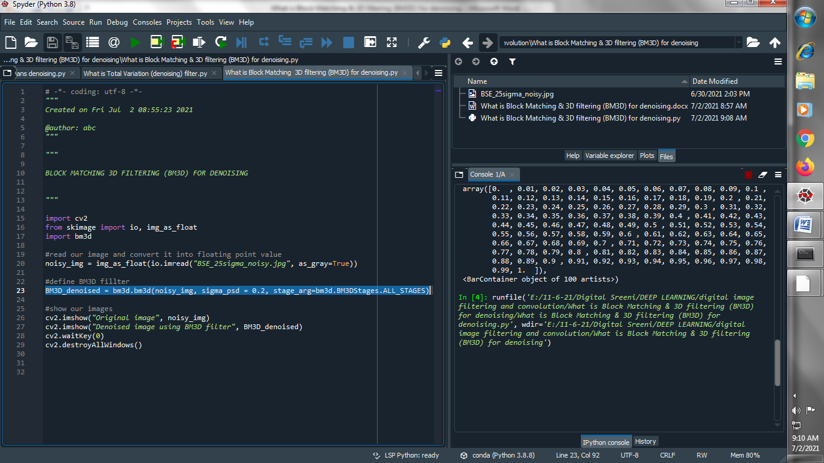

1. **Show our images :**

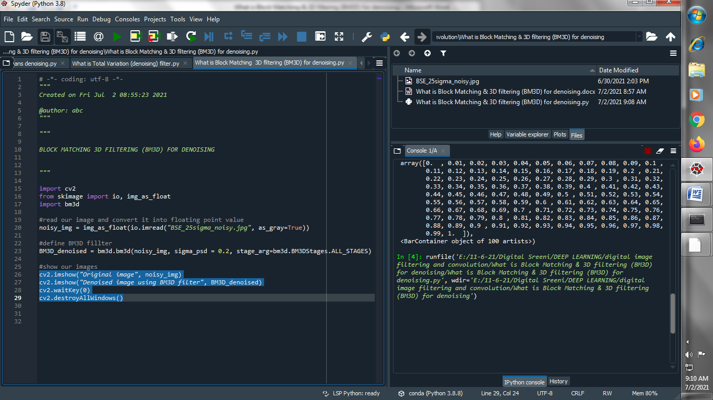

**Output :**

**Original image :**

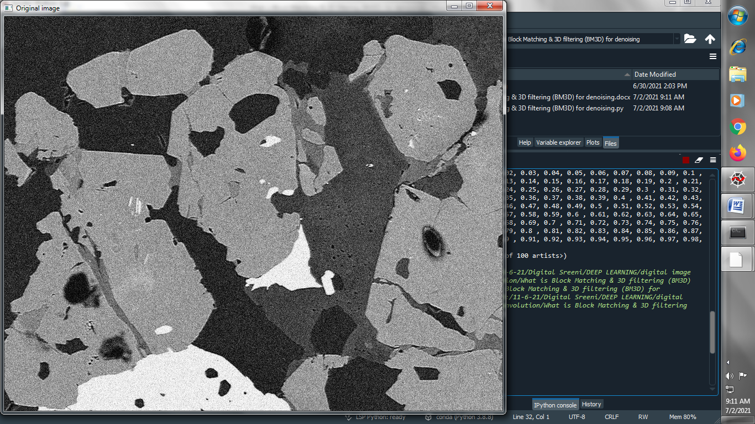

**Denoise image using BM3D filter :**

